**Dión**

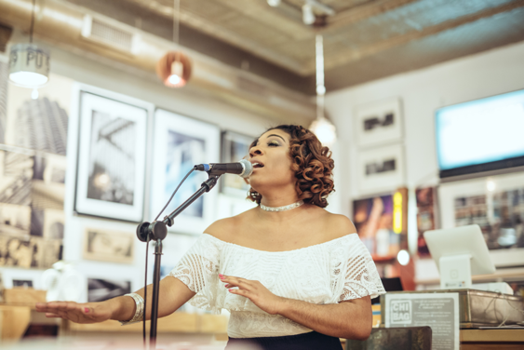

Dión is an emerging singer/songwriter hailing from the South Suburbs of Chicago. Amber’s experience with music goes as far back as 1995 singing in her church. Amber mastered her skills at Mount Holyoke College where she was also a Five College Ethnomusicology Certificate Recipient. During her collegiate experience, Amber had the privilege of participating in a domestic exchange at Spelman College where she was a featured soloist for the Annual Morehouse and Spelman Christmas Carol Concert in 2011.

After graduating from Mount Holyoke College, she returned back to her hometown to create and collaborate with influential artists. Amber has had the opportunity to provide supporting vocals for multiple artists some include PJ Morton, Gene Noble, Erthe St. James, and Harold Green. Amber is also recognized for her work with the Musical Arts Institute on the South Side of Chicago as a Vocal Instructor and Featured Soloist in the “Worthy Cantata” composed and conducted by Lana Manson. Amber has traveled and performed with both Choral Groups and Missions Organizations in Switzerland, Italy, Austria, and South Africa.

Amber describes her musical approach as eclectic and soulful. Amber uses her passion for the technique utilized by classically trained singers and the groove of R&B to provide listeners a thought provoking musical experience. Not just music that is audibly appealing but resonates with the heart of a person.